FinTech – the path-breaking buzz
Prof. Shobha Pillai  Adjunct Faculty  IBS (ICFAI Business School),  MUMBAI.  Email: shobhabpillai@ibsindia.org | Prof. Nitin Bolinjkar  Adjunct Faculty  IBS (ICFAI Business School),  MUMBAI.  Email: nitin.bolinjkar@ibsindia.org | Prof. Naisha Sujan  Adjunct Faculty  IBS (ICFAI Business School),  MUMBAI.  Email: naisha.sujan@ibsindia.org

Introduction
Financial Technology, popularly known as “FinTech” is an industry comprising of companies that use technology to make financial services more efficient. Traditionally, large Banking and Financial institutions have been resistant to change due to their legacy IT systems. Scope for innovation is restricted as they are under constant scrutiny by regulatory bodies and their agility for customer acquisition and service was bound by tedious processes. The FinTech industry came been under focus recently with Berkshire Hathaway’s investment into Paytm for Rs 2500 crore marking Warren Buffett’s first investment in the country. Further, the Indian FinTech software market is forecasted to touch USD 2.4 billion by 2020 from a current USD 1.2 billion, as per NASSCOM.

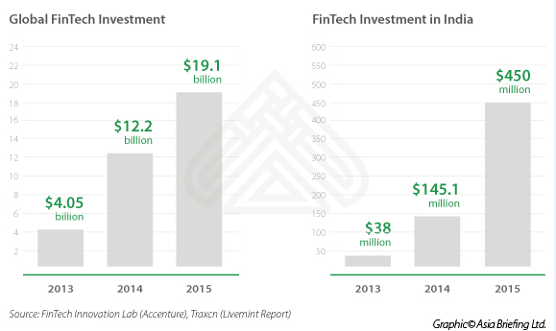
Emergence of FinTech companies has been a win-win situation for both start-ups and larger institutions. Start-ups are typically more flexible and agile equipped with more modern technology expertise and innovation capabilities. By collaboration, larger institutions can gain access to new technologies, whereas start-ups can gain access to funding sources and large customer bases.
However, ensuring regulatory compliance and fraud free payment systems are very difficult to manage for any start-up, so currently most FinTechs are still built on top of existing processes and systems of well established institutions and payment systems. To maintain the dominance banks have enjoyed up to this point, they need to radically redesign their customer-facing assets. If banks fail to overhaul their exteriors to offer a personalized, best-in-class product experience, they will be relegated to supplying the engine for sleeker-looking tech companies in 10 years’ time.
Additionally, the hectic pace of change in payment systems – online, mobile, virtual wallets and smart watches, among others – means that all businesses need to remain alert to the latest trends and developments. Central bank needs to support FinTech phenomena by addressing customer protection issues and ensure authenticity of transactions.
Currently, FinTech companies in India can be broadly classified into three categories
- Aggregators: These companies act as a front end to various financial institutions primarily in lending and insurance sectors. They do not have their own product range most of the time, but provide comparisons based on customer requirements and suggestions for best fitment.
- Backend processing requirements: Since large institutions do not have the expertise to use technology for customer acquisition using latest mobile and internet, they outsource customer behaviour analysis and background checks to these FinTechs. These FinTech companies can create a more diverse and stable credit landscape by gathering data from social-media and other sources to assess the needs of young businesses and borrowers on the fringes of the banking system.
- Specialised players in the payments sector, POS providers and institutions for MSME segment etc.
FinTech has brought down previously not possible cycle time for lending, with companies like Shubh loans and Moneytap, which help consumers avail of credit facilities from FIs, are now trying to enter the lending space and vying for a license from the banking regulator. These companies have been in business for 3-4 years and have now got a taste of Indian consumer behaviour and delinquency trends. A license can bring down borrowing cost, increase margin and have more flexibility to operate, albeit with lot of regulatory requirements.
Case in point is a FinTech like Earlysalary, which caters to youngsters in their first jobs in metros, with average age of 26 and earning about Rs. 30,000 per month. These customers may not be able to get a bank loan, because their credit scores have not matured. They claim that the loan is disbursed within 5 minutes. According to The Boston Consulting Group (BCG), this newly internet-introduced 3-1-0 model implies three minutes to decide, one minute to transfer the money and zero human touch. The firm estimates as many as five million such loans have been disbursed to both consumers and small and medium enterprises.
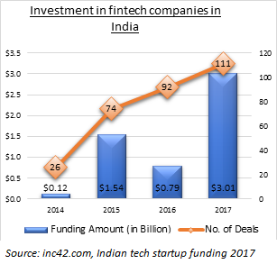

Comparison - Banks and Non Banking Financial Companies (NBFC’s)
At this point, it is prudent to do a comparison of established entities of banks and NBFCs. A bank is the key financial institution, which dominates the entire lending and borrowing landscape of a country. It acts as a financial aggregator, between a depositor and borrower, and is the backbone of a country’s economy. In India, banks are authorised by the Reserve Bank Of India (RBI) to conduct activities such as mobilisation of deposits and withdrawals, granting credit, paying interest, clearing cheques etc.
An NBFC (Non-Banking Financial Company), on the other hand, is a company registered under the Companies Act. They are not banks per say, but just like banks, they are engaged in lending and other activities such as providing loans and advances, credit facility, savings and investment products, etc. Although NBFC’s also deal in hire purchasing, leasing, infrastructure finance, venture capital finance, housing finance, they, unlike banks, cannot accept deposits repayable on demand. This is the key difference between banks and NBFC’s.
The following are some key distinctions between Banks and NBFC’s;
- A Bank is an RBI licensed financial institution that provides banking services to the general public. An NBFC is a company that does not need a RBI banking licence, and can provide all banking services, except taking ‘on demand’ deposits and clearing checks.
- An NBFC is incorporated under the Indian Companies Act, 1956, whereas a bank is registered under Banking Regulation Act, 1949. As the licensing regulations for banks are more stringent than those for NBFC’s, it is mandatory for banks to maintain reserve ratios such as CRR or SLR. As NBFC’s do not come under the purview of banking regulations, they are not required to maintain reserve ratios.
- Foreign Investments of up to 100% is allowed in NBFC’s. Private sector can have only up to 74% foreign investment.
- Traditionally, banking business model is based low risk, high resilience, trust and security. NBFCs were able to cut down the time between application and decision from weeks to days by process innovations. However, these processes are human-intensive.

Disruption by FinTech’s and new financial Ecosystem
The emergence of technologies such as 4G, machine learning algorithms, digital payment gateways and platforms like digital wallets, led to path-breaking innovations in the financial sector. The new buzzwords were eKYC, eSign, UPI, AADHAR, India Stack, API’s and "FinTech".
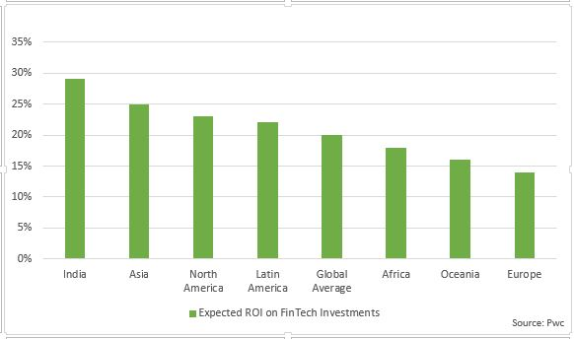
The FinTech model is based on charging a premium for the select niche customer segment that is inclined towards service and the ‘overall experience’. These companies combine agility with personalisation and convenience. These start-ups leverage technology using API’s to deliver results, real-time. They promise ‘credit in a minute’ with zero paperwork, transparency and customer service. Features such as round the clock access, immediate consultation, remote account opening, real-time fund transfers, multi-channel repayments (auto-debit, payment gateway, wallets, UPI, eNACH etc), real-time reconciliation, are their distinct differentiators.
Compared to traditional FIs, new-age FinTech’s are more data-driven. Their lean operating model focuses on agility and customer-centricity. Their flatter organisational structures are more responsive, and can quickly leverage technology innovations to provide a more personalized customer experience.
Also, as most FinTech’s operate on the mobile platform, mobile penetration in India has given FinTech’s a distinct advantage over traditional banks. "400 million smartphones coupled with a tech-savvy millennial population are bringing large numbers of the hitherto un-served or under-served into the mainstream of finance and building distribution funnels at a speed not seen earlier. This is truly a disruptive moment for banks and traditional NBFCs as these new borrowers demand a completely different paradigm for the engagement and fulfilment experiences than the older generation of borrowers," says Shivashish Chatterjee, co-founder DMI Group.
https://m.dailyhunt.in/news/india/english/inc42-epaper-inc/the+shifting+landscape+of+lending+nbfcs+give+banks+a+run+for+their+money-newsid-90952597
In a nutshell.....
Feature | Banks | NBFCs | FinTech
Time to Get Money | Typically 5-7 days | Typically 4-6 days | Typically 1-3 days
Convenience | Low | Medium | High
Reliability of Customer Service | Low | Medium | High
Interest Rates | 10-15% | 14-20% | 20-27%
Flexibility in Rules | Low | Low | Medium
Paperwork Involved | High | Medium | Low
Specialized Products | Rarely | Frequently | Frequently
Process Comparison
Process Step | Banks | NBFCs | FinTech
Document verification | Generally manual | Generally manual | Generally automated
Agreement signing | Generally manual | Generally manual | Generally automated
KYC | Generally based on self attestation, signing of photo copies | Generally based on self attestation, signing of photo copies or eKYC for digitally advanced NBFCs | Typically eKYC or scan image upload based
Other paperwork (e.g. cheques) | Generally high | Generally high | Generally low
https://blog.credy.in/2018/06/25/banks-vs-nbfcs-vs-fintechs-how-to-choose-your-loan/
Ecosystems have emerged around these FinTechs, Banks and NBFC’s, consisting of multiple interdependent stakeholders, which will eventually lead to better financial services being delivered cheaper and quicker. Many banks, including Barclays, Citibank, Goldman Sachs working closely with FinTech’s. Collaboration between ICICI Bank and Paytm is a good example of how banks have started partnering with FinTech. BNP Paribas, HSBC, UBS and Deutsche Bank have invested into FinTech firms, whereas some banks are even acquiring FinTech start-ups to counter these challenges.
https://m.dailyhunt.in/news/india/english/inc42-epaper-inc/the+shifting+landscape+of+lending+nbfcs+give+banks+a+run+for+their+money-newsid-90952597
India stack – backbone of digital financial services in India.
Aadhaar is one of the first ‘Biometric authentication and identification’ initiative to be deployed anywhere in the world. Identity is a huge problem in every part of the world with people migrating more than ever, and they lose their identity and credit worthiness whenever they move to a new country. In India, the biggest challenge in terms of Identity is about inclusion of 1.3 billion people (67.5 % rural population ) using a better and more efficient mechanism to provide basic education, health and food services - and the Aadhaar identity scheme was conceived as a means to do this.
As India as a country matures regarding the use of Aadhaar, much of the backbone infrastructure for digital India in India, is being built on the framework of India Stack - driven by Aadhaar and eKYC. IndiaStack is a set of APIs that allows government, businesses and developers to utilise a unique digital Infrastructure to solve India’s hard problems towards presence-less, paperless, and cashless service delivery impacting the 1.2 billion people. Highlights of this initiative are as below:

Aadhaar
Aadhaar authentication is now fairly well established wherein Aadhaar Number, along with other attributes including biometrics, are submitted online to the CIDR for its verification on the basis of information or data or documents available with it. At a high level, authentication can be ‘Demographic Authentication’ and/or ‘Biometric Authentication’.
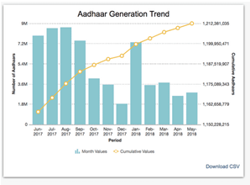

eKYC
Aadhaar eKYC is a paperless Know Your Customer (KYC) process, wherein the Identity and Address of the subscriber are verified electronically through Aadhaar Authentication on real time basis. It can be used as an alternative to the current KYC process which is done on the basis of physical photocopies of the original documents (ID proof and Address proof). In addition, it also provides the resident’s mobile number and email address to the service provider, which helps in further streamlining the process of service delivery.
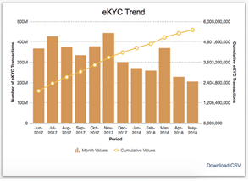

UPI
“Unified Payment Interface” (UPI) enables all bank account holders in India to send and receive money instantly from their smartphones without the need to enter bank account information or net banking userid/ password. For using UPI, users need to create a Virtual Payment Address (VPA) of their choice and link it to any bank account. Once the link is defined, The VPA acts as their financial address and users need not remember beneficiary account number, IFSC codes or net banking user id/password for sending or receiving money. UPI can be used to for Peer-Peer, Peer-Merchant & Business-Business payment transactions.
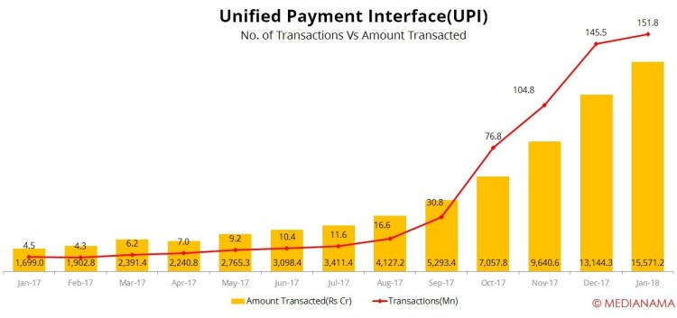

DigiLocker
Targeted at the idea of paperless governance, Digital Locker is a platform for issuance and verification of documents & certificates in a digital way, thus eliminating the use of physical documents. Indian citizens, who sign up for a DigiLocker account get a dedicated cloud storage space that is linked to their Aadhaar (UIDAI) number. Organizations that are registered with Digital Locker can push electronic copies of documents and certificates (e.g. driving license, Voter ID, School certificates) directly into citizen’s lockers.
Citizens can also upload scanned copies of their legacy documents in their accounts. These legacy documents can be electronically signed using the eSign facility.

eSign
eSign service allows applications to replace manual paper based signatures by integrating an API which allows an Aadhaar holder to electronically sign a form/document anytime, anywhere, and on any device legally in India. eSign service facilitates significant reduction in paper handling costs, improves efficiency, and offers convenience to customers
The eSign service is governed by e-authentication guidelines. While authentication of the signer is carried out using Aadhaar e-KYC services, the signature on the document is carried out on a backend server of the e-Sign provider. eSign services are facilitated by trusted third party service providers – currently Certifying Authorities (CA) licensed under the IT Act.
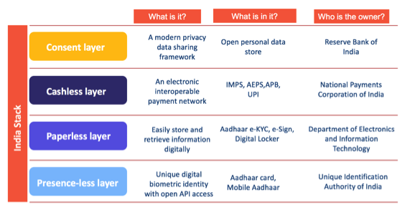
Thus Aadhaar, is only the bottom most layer in a value-adding stack of offerings from the government and other parties. The paperless layer, that uses Aadhaar identity data to provide e-KYC (know your customer) and e-documentation services is today one of the most cost-efficient, with over 16.96 billion e-KYCs already done by consumers, helping the Government save more than $7 billion so far. The cashless layer has taken a huge leap forward with the deployment of Unified Payments Interface (UPI), launched in 2016, an instant payments system that enables peer-to-peer (P2P) transfer of money between bank accounts with the help of open APIs and enablers using them.
Thus FinTechs, developers, banks, healthcare providers, non-profit organisations and others can use to build offerings and value-added services using Indiastack that benefit the end consumers. In an interesting real life example, Reliance Jio leveraged e-KYC and e-Sign to easily and efficiently issue mobile SIM cards. The entire SIM activation process that previously took 3-5 days now takes only a few minutes, thus significantly improving customer experience and overall efficiency.

Challenges around data security
The biggest challenge, Aadhaar and Indiastack face are around data privacy and security. There have been some signifcant reports of Aadhaar consumer data being leaked
– Anonymous people were selling Aadhaar data over social media for small amount. Reporters were able to access login information of consumers through the data sellers
-- Reports of a government utility firm (that has access to Aadhaar data for purposes of subsidies etc) was found to be using such a vulnerable platform for storing data that anyone could have obtained unique Aadhaar data by hacking into it.
Aadhaar is not like the US Social Security number or the UK National Insurance number, as those are mostly used for purposes of social benefits and do not have biometric data. Aadhaar is the largest sensitive data store in the world, with over 1.1 billion unique data points stored in it – connected to hundreds of government agencies and data shared with thousands of private companies – which, on its own, deserves the best security system is possible.
Once the security concerns are resolved, IndiaStack can dramatically transform the way financial institutions function today by transforming to become a completely digital entity. All banking transactions can be accessible in the online world with efficient and secure means to protect consumer data. Multiple key banking functions like account opening, money transfers, payments, loan approvals and disbursements can built via the many layers of IndiaStack.
Few examples are :
- Account opening, as explained earlier can be completed instantly through a simple Aadhaar eKYC verification process, which has been implemented by newer banks like IDFC bank and Kotak bank already.
- Loan approvals can be completed online with the customer providing access to the required information, documentation and other checks through the electronic consent architecture and Digital Locker.
- All bank related documentation can also be digitally signed through E-sign and securely stored and retrieved online as and when needed from the Digital Locker.
- Loan Disbursement can be routed digitally to the customer’s bank account and payments and money transfers by the customer can be initiated effortlessly through the bank’s app via UPI.
These use cases are only a few examples of how IndiaStack can be leveraged. In reality, this unique technology stack can provide organizations the power to re-invent systems and processes apart from financial sector as well. For instance, the healthcare sector can easily tap into Digital Locker to store and retrieve relevant medical record, through the consent of patients. This makes healthcare portable, meaning that people can access healthcare facilities at any place on short notice without the worry of having to carry patient medical history documents. Similarly, the travel and tourism industry can tap on Aadhaar eKYC for passenger verification, tickets can be purchased using UPI and stored on Digital Locker, and retrieved at the time of travel through the consent layer. The application opportunities for IndiaStack is massive and both private and public agencies can leverage the stack to optimise and digitize processes.

Need for regulation in the FinTech space
FinTech is an amalgamation of financial services, information technology and telecom infrastructure. Its heavy dependence on Information Technology and internet, leads to a greater need for regulation as online financial transactions are prone to several security threats. Further, the FinTech space is exposed to the risk of money laundering, terrorist financing, etc. FinTechs, unlike traditional banks, may not have a very clear idea of regulators and governing bodies and the rules and regulations that they have to adhere to. This is due to several factors. Every FinTech firm has a unique and dynamic business model that functions on the premise of innovation. Innovation leads to constant change and hence governing such companies becomes difficult. As the FinTech industry matures, regulations will need to keep pace with its evolution so that the four areas below are covered:
- Data Privacy – Misuse of data across the globe is a high priority issue and FinTechs must adopt very high standards of data security and privacy and allow only consent based access to sensitive information.
- Data Security – Data must be protected against cyber security attacks
- Risk Management – FinTechs must also follow the similar risk standards as their larger counterparts to prevent money laundering, terrorism financing, bad loans and reputational risk losses.
- Operating Model – Even though they have a light and dynamic operating model, well-defined governance model and management of funds

FinTech has brought about efficiency improvements, risk reduction and greater financial inclusion. However, Regulatory uncertainty and confusion in the FinTech sector is one of the major challenges for the rapidly evolving FinTech sector. The problem starts firstly because of the involvement of several regulatory bodies, RBI being the obvious stakeholder, SEBI for intermediaries in the securities market and the Insurance Regulatory and Development Authority (IRDA) for insurance-related businesses. National Payments Corp. of India also fits in due to payment related services being at the core of FinTech. The draft Payments and Settlements Systems Bill has set up an independent payments regulator. The Unique Identification Authority of India (UIDAI) is in the mix too via Aadhaar’s use and Indiastack APIs (for example e-KYC by FinTechs). Though, Supreme Court’s judgement left no scope for private companies using Aadhaar, Finance ministry is working on passing new legislation that would allow private companies back in. Then there’s the Srikrishna Committee for data privacy and security. Last but not the least, and the Telecom Regulatory Authority of India (TRAI) due to the usage of internet based technologies.
Currently there are no explicit prohibitions on FinTech business in India. However the Government is looking at regulating the various verticals of the sector. Not all market entrants may be able to participate in certain types to FinTech business. For instance, only banks which meet the eligibility criteria are allowed to issue open prepaid instruments (PPIs). A PPI is an instrument which can be used to make payments against goods and services and withdraw money from ATMs.
As industry is maturing, regulations are evolving in some areas, for example for P2P lending business:
Registration: All firms engaging in Peer to peer lending will be registered as NBFC with the RBI. Existing NBFC-P2P have been given 3 months to apply for registration
Net owned funds: An entity seeking registration as a P2P NBFC is required to have atleast Rs 2 crore net owned fund. This is to ensure that only financially serious players enter the market.
Leverage ratio : To ensure stability RBI has recommended a Debt to Equity ratio of not more than 2:1.
Use of Escrow accounts: Any fund transfer between participants on a P2P lending platform shall be through an escrow account, which will be operated by a trustee.

Cap on lending and borrowing amount:
RBI has set the following caps on the lending and borrowing amount to ensure diversification of risk
Aggregate exposure of a lender to all his/her borrowers at any point, across all P2Ps | Max upto Rs 10 lakh
Aggregate loans taken by a borrower at any point of time, across all P2Ps | Max upto Rs 10 lakh
Exposure of a single lender to a particular borrower | Max upto Rs 50000

Submission of data to Credit Information Companies (CICs)
All P2P lending NBFCs are required to become members of all CICs and submit them all historical data. This is expected to bring more stability and credibility and reduce default risks.

Scope of Activities
An NBFC – P2P shall –
- act as an intermediary providing an online marketplace or platform to the participants involved in Peer to Peer lending;
- not raise deposits
- not lend on its own;
- not provide or arrange any credit enhancement or credit guarantee;
- not facilitate or permit any secured lending linked to its platform; i.e. only clean loans will be permitted;
- not hold, on its own balance sheet, funds received from lenders for lending, or funds received from borrowers for servicing loans
- not cross sell any product except for loan specific insurance products;
- not permit international flow of funds;
- ensure adherence to legal requirements applicable to the participants as prescribed under relevant laws.
- store and process all data relating to its activities and participants on hardware located within India.
(Source : www.rbi.org)

FinTech – Insights into future
In these times of rapidly changing technology and telecom infrastructure, only one thing is certain – change. Some of the upcoming game changing trends can be listed as below:
- Indiastack as a platform will settle down overcoming the initial teething issues and can be leveraged to provide the required impetus for digitisation.
- Next-gen chatbots – 2017 saw several major banks in India such as HDFC, ICICI, and YES Bank, amongst others, adopting chatbots for supporting customer interactions. The evolution of a chatbot could be best described as more exponential than linear. chatbots are expected to evolve with improved quality of interactions, speed of responses, and accuracy in decision-making.
- Machine Learning – Banks in 2018 started adopting new regression models powered by machine learning to deliver better offerings. The brightest data scientists are involved and they are aided by insights into customer behaviour, expectations and responses. These insights will be gained by adopting big data tools and will enable banks to predict customer needs and meet them in a customised manner.
- Blockchain – As NITI Aayog is creating ‘IndiaChain’, India’s largest blockchain network, to reduce fraud, speed up contract enforcement, and increase transparency. Several major players have already begun pilot projects to measure the feasibility of adopting blockchain into their ecosystems.
As blockchain virtually cannot be hacked due to time stamps that mark a data entry in a distributed ledger, banks will explore options to leverage the power of blockchain to transform backend operations.
- Smart workflows – With the help of embedded AI aiding the backend operations of banks, they will be able to quickly identify bottlenecks in their operation workflows and bring in significant improvements in process efficiencies.
- Automated personalisation – Banks will leverage the power of FinTech to personalise the offerings that users see on all their devices. Banks will change the appearance of apps based on actual usage. This will make users feel more connected with banks and it will also set the stage for efficient self-service. There will also be advancements in providing pre-filled data to users based on their previous interaction history, preferences and banking habits.
- Open banking – With initiatives such as Unified Payments Interface (UPI) and Aadhaar Enabled Payment System (AEPS), banking will become more ‘open’ in future. With more APIs exposed by banks, the process of carrying out payments and other banking transactions would be greatly quickened as well as simplified.
- Physical and digital merger – FinTech has made it possible for banks to reach customers who are data rich but credit poor. In a country like India, where so many people still don’t have access to banking facilities, FinTech works better by offering a ‘phygital’ (a combination of physical and digital) experience. The objective here is effective self-service that enables customers to walk into a branch and make use of basic automated services. Canara Bank has successfully implemented such a system with CANDI to remove the boundaries between physical and digital banking.
- Extended digital coverage – Until now, most digital banking solutions have been primarily targeted at retail customers. Soon, banks will extend digital coverage to other areas such as corporate banking and SME banking and also transform their internal operations to derive the best out of digital transformation initiatives.
- Agile architecture – Digital solutions are here to stay and as timelines shrink, budgets tighten, and lifecycles shorten, banks will follow new architecture paradigms such as micro apps, micro services and more. These will enable banks to introduce changes significantly faster with minimal impact on existing deployments and services.
- Security – Data is the new oil and with so much data being generated every second, hackers are constantly devising ways to acquire it. As most cyber security measures up till now have been reactive rather than preventive in nature, banks will now begin to adopt additional measures to ensure data security at all stages using a combination of encryption, OTPs, biometric authentication and more.
Conclusion:
Over the last two years, the government and regulators have adopted a supportive approach towards the FinTech industry. Until 2017, most of the regulators appeared to be treating FinTechs on par with traditional, well-established firms rather than as the upcoming industry they represent. Considering the dynamic nature of this industry with each FinTech having a unique serice and operating model, it is required that the regulations cover 360 degree view of business and are adaptable.
Report from RBI’s Inter-Regulatory Working Group on FinTech and Digital Banking, which included representatives from all financial sector regulators, select banks, FinTech firms and consultants, and rating agencies, undertook a comprehensive study of granular aspects of FinTech and its implications for the financial sector. The objective was to review and reorient appropriately the regulatory framework and respond to the dynamics of FinTech.
The report encourages the setting up of a regulatory sandbox along the lines of those established by the Monetary Authority of Singapore and the UK’s Financial Conduct Authority. The unique advantage of a sandbox is that it allows FinTech start-ups to test out new services and assess their risks before they are taken to market. FinTech firms and regulators can work together and tweak existing regulations, enabling firms to test their products for a limited time and among a limited number of customers.
References:
https://indiastack.org
analyticsindiamag.com/fintech-vs-banking-the-difference-between-banks-new-entrants/
https://m.dailyhunt.in/news/india/english/inc42-epaper-inc/the+shifting+landscape+of+lending+nbfcs+give+banks+a+run+for+their+money-newsid-
https://www.livemint.com/
https://blog.credy.in/2018/09/10/digital-lending-fintech-bank-synergy-means-customer-is-the-winner/
https://blog.credy.in/2018/06/25/banks-vs-nbfcs-vs-fintechs-how-to-choose-your-loan/
http://blog.cashsuvidha.com/3-advantages-fintech-banks-nbfcs/
https://yourstory.com/2017/11/top-10-fintech-trends-influence-banking-industry-2018/
https://www.communicationstoday.co.in

